Metal Touch Sensor  
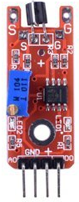

Overview

Metal touch switches are transistor switches that conduct electricity when receiving electromagnetic signals, such as when touched by a charged body like as your fingers. This module packages a metal touch sensor into a convenience circuit that both reports the strength of that electromagnetic signal as an analog output, and whether that signal exceeds a certain user-definable threshold as a digital output. This experiment uses the Raspberry Pi to collect and report those output values to the command line interface.

Experimental Materials

Raspberry Pi x1

Breadboard x1

Metal Touch sensor x1

ADC0832 x1

Dupont jumper wires

Experimental Procedure

1. If you have not done so already, prepare your development system by installing the Python interpreter, RPi.GPIO library, and wiringPi library as described in READ_ME_FIRST.TXT.
2. Install the ADC0832 analog/digital converter IC and metal touch sensor on your breadboard, and use Dupont jumper wires to connect them to each other and your Raspberry Pi as illustrated in the Wiring Diagram below.
3. Execute the sample stored in this experiment’s subfolder.

If using C, compile and execute the C code:  
  
cd Code/C  
gcc metalTouch.c -o metalTouch.out –lwiringPi  
./metalTouch.out

If using Python, launch the Python script:  
  
cd Code/Python  
python metalTouch.py

1. Make experimental observations. When you touch the sensor with your fingers or with metal, the command line interface should report the touch (when the threshold is exceeded), as well as an increased value for the analog sensor. You can adjust the threshold of sensitivity by varying the onboard potentiometer.

Wiring Diagram

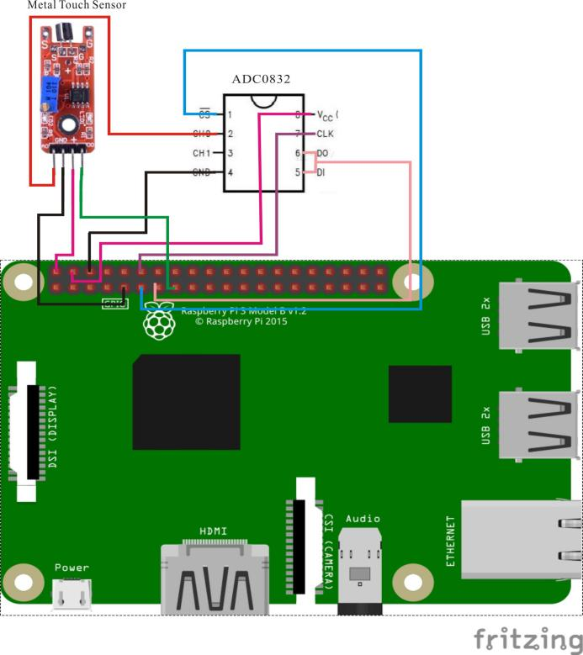

ADC0382 pin position:

CS ↔ Raspberry Pi Pin 11

CLK ↔ Raspberry Pi Pin 12

DI ↔ Raspberry Pi Pin 13

D0 ↔ Raspberry Pi Pin 13

CH0 ↔ Metal Touch Sensor Pin A0

VCC ↔ Raspberry Pi +5V

GND ↔ Raspberry Pi GND

Metal Touch Sensor pin position:

A0 ↔ ADC0382 Pin CH0

D0 ↔ Raspberry Pi Pin 15

GND ↔ Raspberry Pi GND

"+" ↔ Raspberry Pi +5V

Sample Code

Python Code

#!/usr/bin/env python

import RPi.GPIO as GPIO

import ADC0832

import time

Touch_DO_PIN = 15

def init():

GPIO.setmode(GPIO.BOARD)

GPIO.setup(Touch_DO_PIN, GPIO.IN, pull_up_down = PUD_DOWN)

ADC0832.setup()

def loop():

print 'Please touch....\n'

while True:

global digitalVal

print 'Current analog value is %d'% ADC0832.getResult(0)

digitalVal = GPIO.input(Touch_DO_PIN)

if(digitalVal == 1):

print 'DO is %d' % digitalVal

print "Touch detected..."

time.sleep(0.2)

else:

pass

if __name__ == '__main__':

init()

try:

loop()

except KeyboardInterrupt:

ADC0832.destroy()

print "The end !"

C Code

#include <wiringPi.h>

#include <stdio.h>

#include <string.h>

#include <errno.h>

#include <stdlib.h>

#define ADC_CS 0

#define ADC_CLK 1

#define ADC_DIO 2

#define Touch_DO_Pin 3

typedef unsigned char uchar;

typedef unsigned int uint;

uchar get_ADC_Result(void)

{

uchar i;

uchar dat1=0, dat2=0;

digitalWrite(ADC_CS, 0);

digitalWrite(ADC_CLK,0);

digitalWrite(ADC_DIO,1); delayMicroseconds(2);

digitalWrite(ADC_CLK,1); delayMicroseconds(2);

digitalWrite(ADC_CLK,0);

digitalWrite(ADC_DIO,1); delayMicroseconds(2);

digitalWrite(ADC_CLK,1); delayMicroseconds(2);

digitalWrite(ADC_CLK,0);

digitalWrite(ADC_DIO,0); delayMicroseconds(2);

digitalWrite(ADC_CLK,1);

digitalWrite(ADC_DIO,1); delayMicroseconds(2);

digitalWrite(ADC_CLK,0);

digitalWrite(ADC_DIO,1); delayMicroseconds(2);

for(i=0;i<8;i++)

{

digitalWrite(ADC_CLK,1); delayMicroseconds(2);

digitalWrite(ADC_CLK,0); delayMicroseconds(2);

pinMode(ADC_DIO, INPUT);

dat1=dat1<<1 | digitalRead(ADC_DIO);

}

for(i=0;i<8;i++)

{

dat2 = dat2 | ((uchar)(digitalRead(ADC_DIO))<<i);

digitalWrite(ADC_CLK,1); delayMicroseconds(2);

digitalWrite(ADC_CLK,0); delayMicroseconds(2);

}

digitalWrite(ADC_CS,1);

pinMode(ADC_DIO, OUTPUT);

return(dat1==dat2) ? dat1 : 0;

}

int main(void)

{

uchar digitalVal = 1;

uchar analogVal = 0;

if(wiringPiSetup() == -1){ //when initialize wiring failed,print messageto screen

printf("setup wiringPi failed !");

return 1;

}

pinMode(ADC_CS, OUTPUT);

pinMode(ADC_CLK, OUTPUT);

pinMode(Touch_DO_Pin, INPUT);

pullUpDnControl(MIC_DO_Pin, PUD_DOWN);

printf("Please touch...\n");

while(1)

{

printf("Current analog value is %d.\n", get_ADC_Result());

if((digitalVal = digitalRead(Touch_DO_Pin)))

{

printf("Do is %d.\n", digitalVal);

printf("Touch detected...");

}

delay(200);

}

return 0;

}